O’ZBEKISTON RESPUBLIKASI OLIY TA’LIM,FAN VA INNOVATSIYA
VAZIRLIGI
ABU RAYXON BERUNIY NOMIDAGI URGANCH DAVLAT UNIVERSITETI

Kompyuter injineringgi fakulteti
„Kompyuter ilmlari va dasturlash texnologiyalari” yo’nalishi 234-guruh
Komilova Farangizning
“Web texnologiya ” fanidan
4-laboratoriya mashg’uloti

Qabul qildi:________________________________________________

Urganch-2025
Laboratoriya ishi №4
Mavzu: Jadval yaratish va uni formatlash
Ishdan maqsad: HTML tilida jadval yaratish, kataklarni birlashtirish va jadval atributlari yordamida formatlashni o‘rganish.
1. Nazariy qism
HTML tilida jadval yaratish uchun <table> tegi ishlatiladi. Asosiy elementlari:
- <tr> – satr (row)
- <td> – katak (data cell)
- <th> – sarlavha katagi (header cell)
- <caption> – jadval sarlavhasi
Asosiy atributlar:
- border – jadval va katak chegarasi
- cellpadding – katak ichidagi bo‘shliq
- cellspacing – kataklar orasidagi bo‘shliq
- align – jadvalning joylashuvi
- bgcolor – fon rangi
- colspan – katakni bir nechta ustunga kengaytirish
- rowspan – katakni bir nechta satrga kengaytirish
- <caption> – jadval nomi
Jadval — bu ma'lumotlarni satrlar (qatordagi yozuvlar) va ustunlar (malumot turi bo‘yicha bo‘linish) shaklida tartiblab berish usuli. Web sahifalarda jadvaldan ko‘pincha ma'lumotlarni ko‘rsatishda (misol uchun: mahsulotlar ro‘yxati, foydalanuvchi ma’lumotlari), statistikalar yoki hisobotlarda, savdo ma'lumotlarini va boshqa ixtisoslashgan ma’lumotlarni tartib bilan ko‘rsatishda foydalaniladi.Jadval ma'lumotni yanada oson tushunish va tahlil qilish imkonini beradi, shuningdek, sahifani vizual jihatdan tartibli qiladi.
HTML (HyperText Markup Language) veb sahifalarning asosiy tuzilishini belgilaydi. Jadval yaratishda quyidagi teglar ishlatiladi:
<table> — jadvalning asosiy konteyneri. Barcha jadval elementlari shu teg ichida joylashadi.
<thead> — jadvalning sarlavha (header) qismi. Ko‘pincha ustunlarning nomlari shu yerga yoziladi.
<tbody> — jadvalning ma'lumot qismi. Asosiy ma'lumotlar shu yerda bo‘ladi.
<tfoot> — (majburiy emas) jadvalning pastki qismi, ko‘pincha umumiy hisobot yoki hisoblar uchun ishlatiladi.
<tr> — jadvaldagi bitta satr (qatorda joylashgan barcha hujayralar).
<th> — jadval sarlavha ustunlari uchun teg. Ularning matni qalin va markazlashtirilgan bo‘ladi.
<td> — ma'lumot hujayralari (table data), odatiy jadval katakchalari.
Misol:
<table>
<thead>
<tr>
<th>Ism</th>
<th>Yosh</th>
<th>Kasb</th>
</tr>
</thead>
<tbody>
<tr>
<td>Ali</td>
<td>25</td>
<td>Dasturchi</td>
</tr>
</tbody>
</table>
2. Amaliy qism
Mevalar jadvalining web saytini yaratish
Kod qismi:
<!DOCTYPE html>
<html lang="uz">
<head>
<meta charset="UTF-8" />
<meta name="viewport" content="width=device-width, initial-scale=1" />
<title>Mevalar Jadvali</title>
<style>
body {
font-family: Arial, sans-serif;
background: #f4f4f9;
margin: 20px;
}
table {
width: 100%;
border-collapse: collapse;
box-shadow: 0 2px 8px rgba(0,0,0,0.1);
background: rgb(48, 83, 59);
}
th, td {
padding: 12px 15px;
border: 1px solid #dddddd;
text-align: center;
}
th {
background-color: #5a9bd4;
color: white;
}
tr:nth-child(even) {
background-color: #f9f9f9;
}
img {
width: 60px;
height: 60px;
object-fit: cover;
border-radius: 8px;
}
a {
color: #2a72d8;
text-decoration: none;
font-weight: bold;
}
a:hover {
text-decoration: underline;
}
</style>
</head>
<body>
<h2>Mevalar Jadvali</h2>
<table>
<thead>
<tr>
<th>Id</th>
<th>Meva Rasmi</th>
<th>Malumot</th>
<th>Havola</th>
</tr>
</thead>
<tbody>
<tr>
<td>1</td>
<td><img src="https://upload.wikimedia.org/wikipedia/commons/1/15/Red_Apple.jpg" alt="Olma" /></td>
<td>Olma - vitaminlarga boy, sog'liq uchun foydali meva.</td>
<td><a href="https://upload.wikimedia.org/wikipedia/commons/1/15/Red_Apple.jpg" target="_blank">Olma rasmi</a></td>
</tr>
<tr>
<td>2</td>
<td><img src="https://upload.wikimedia.org/wikipedia/commons/8/8a/Banana-Single.jpg" alt="Banan" /></td>
<td>Banan - energiya manbai, potasiyga boy.</td>
<td><a href="https://upload.wikimedia.org/wikipedia/commons/8/8a/Banana-Single.jpg" target="_blank">Banan rasmi</a></td>
</tr>
<tr>
<td>3</td>
<td><img src="https://media.istockphoto.com/id/1151868959/photo/single-whole-peach-fruit-with-leaf-and-slice-isolated-on-white.jpg?s=612x612&w=0&k=20&c=RLTbnKnN6w85oXn4qA8y8WYN3OMpGxEDc1nI7VY0gWU=" alt="Shaftoli" /></td>
<td>Shaftoli - shirin va sersuv meva, tolaga boy.</td>
<td><a href="https://upload.wikimedia.org/wikipedia/commons/9/9f/Peach_and_cross_section.jpg" target="_blank">Shaftoli rasmi</a></td>
</tr>
<tr>
<td>4</td>
<td><img src="https://static.vecteezy.com/system/resources/previews/030/493/883/non_2x/ripe-yellow-pear-with-green-leaf-isolated-on-a-white-background-ai-generated-free-photo.jpg" alt="Nok" /></td>
<td>Nok - hazm qilishni yaxshilovchi, yumshoq ta'mga ega.</td>
<td><a href="https://upload.wikimedia.org/wikipedia/commons/9/94/Pear_DS.jpg" target="_blank">Nok rasmi</a></td>
</tr>
<tr>
<td>5</td>
<td><img src="https://media.istockphoto.com/id/489520104/photo/green-grape-isolated-on-white-background.jpg?s=612x612&w=0&k=20&c=9kg_3pMeBKYnHHjx2JECF61QwzxTikLaQ2w-6A5tOO0=" alt="Uzum" /></td>
<td>Uzum - antioksidantlarga boy, sharob tayyorlashda ishlatiladi.</td>
<td><a href="https://upload.wikimedia.org/wikipedia/commons/f/fb/Table_grapes_on_white.jpg" target="_blank">Uzum rasmi</a></td>
</tr>
<tr>
<td>6</td>
<td><img src="https://media.istockphoto.com/id/157358797/photo/ripe-fresh-pomegranate-fruit.jpg?s=612x612&w=0&k=20&c=8BaENR2JLkhnDGxw_gEvBjt_BzKfJoc4iCfxkTGNwSw=" alt="Anor" /></td>
<td>Anor - qonni tozalovchi va immunitetni oshiruvchi meva.</td>
<td><a href="https://upload.wikimedia.org/wikipedia/commons/8/8d/Pomegranate_closeup.jpg" target="_blank">Anor rasmi</a></td>
</tr>
<tr>
<td>7</td>
<td><img src="https://t4.ftcdn.net/jpg/00/61/93/47/360_F_61934758_ABnaExXlhWUvUQ7PdGuyGqbGoVO13Hc3.jpg" alt="Anjir" /></td>
<td>Anjir - tola va vitaminlarga boy, hazmni yaxshilaydi.</td>
<td><a href="https://upload.wikimedia.org/wikipedia/commons/1/1b/Ficus_carica_Fig_Fruit.jpg" target="_blank">Anjir rasmi</a></td>
</tr>
<tr>
<td>8</td>
<td><img src="https://media.istockphoto.com/id/533381303/photo/cherry-with-leaves-isolated-on-white-background.jpg?s=612x612&w=0&k=20&c=6BV79sui5Hc6lj555eV_ePiGlKfdZveIG9B5hIWidug=" alt="Olcha" /></td>
<td>Olcha - antioksidantlarga boy, yurak sog'lig'ini qo'llab-quvvatlaydi.</td>
<td><a href="https://upload.wikimedia.org/wikipedia/commons/e/e2/Prunus_cerasus_berries.jpg" target="_blank">Olcha rasmi</a></td>
</tr>
<tr>
<td>9</td>
<td><img src="https://upload.wikimedia.org/wikipedia/commons/d/d3/Kiwi_aka.jpg" alt="Kivi" /></td>
<td>Kivi - C vitamini va tolaga boy, immunitetni oshiradi.</td>
<td><a href="https://upload.wikimedia.org/wikipedia/commons/d/d3/Kiwi_aka.jpg" target="_blank">Kivi rasmi</a></td>
</tr>
<tr>
<td>10</td>
<td><img src="https://www.shutterstock.com/image-photo/tangerine-mandarin-fruit-leaves-isolated-260nw-1390439027.jpg" alt="Mandarin" /></td>
<td>Mandarin - C vitamini manbai, immunitetni mustahkamlaydi.</td>
<td><a href="https://www.google.com/url?sa=i&url=https%3A%2F%2Fwww.shutterstock.com%2Fsearch%2Fmandarin-orange&psig=AOvVaw3BT7aI_TvJYddrkgYwOgEM&ust=1760203007104000&source=images&cd=vfe&opi=89978449&ved=0CBIQjRxqFwoTCMj1yKqRmpADFQAAAAAdAAAAABAE" target="_blank">Mandarin rasmi</a></td>
</tr>
</tbody>
</table>
</body>
</html>
Kod natijasi:
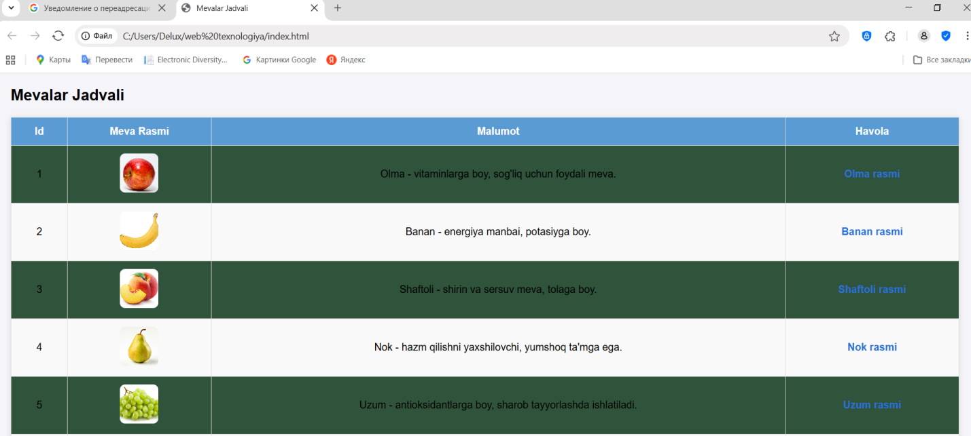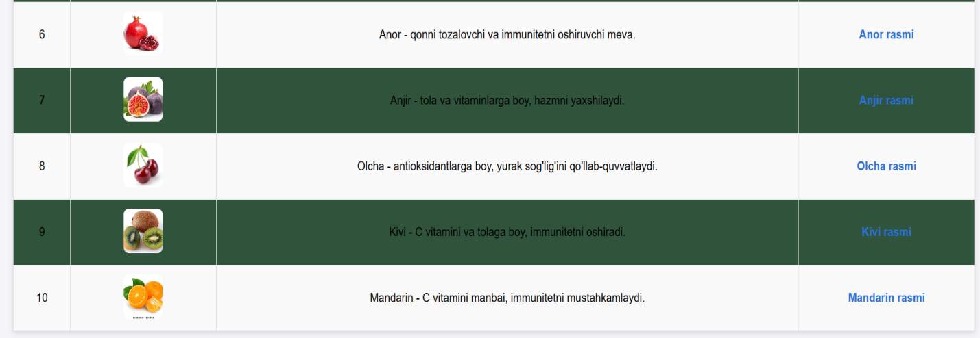
Xulosa
Jadval HTML sahifalarda ma'lumotlarni tartibli va oson tushunarli ko‘rinishda taqdim etish uchun qulay vositadir. Jadval yaratishda <table>, <thead>, <tbody>, <tr>, <th>, va <td> teglaridan foydalaniladi. Jadvalning ko‘rinishi va dizayni CSS yordamida sozlanadi, bu esa unga rang, chegara, kataklar o‘lchami, matn joylashuvi va boshqa vizual xususiyatlarni beradi. Jadvalni formatlash orqali ma'lumotlar yanada aniqroq, chiroyli va o‘qilishi oson bo‘ladi.

